Before Pruning YOLOv5

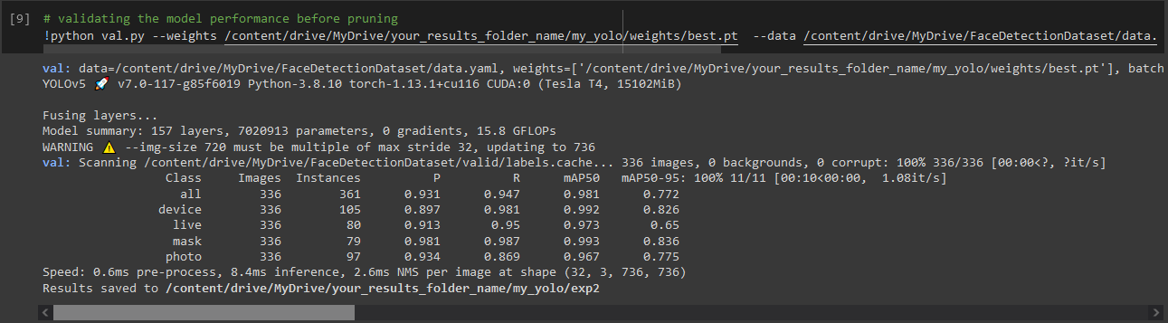

Pruning 10% of weights of the trained model on our custom dataset

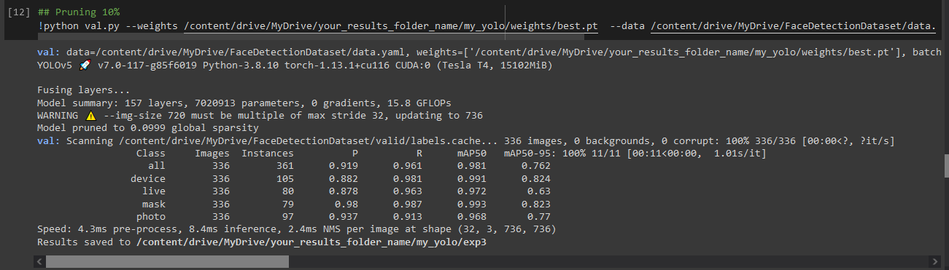

Pruning 20% of weights of the trained model on our custom dataset

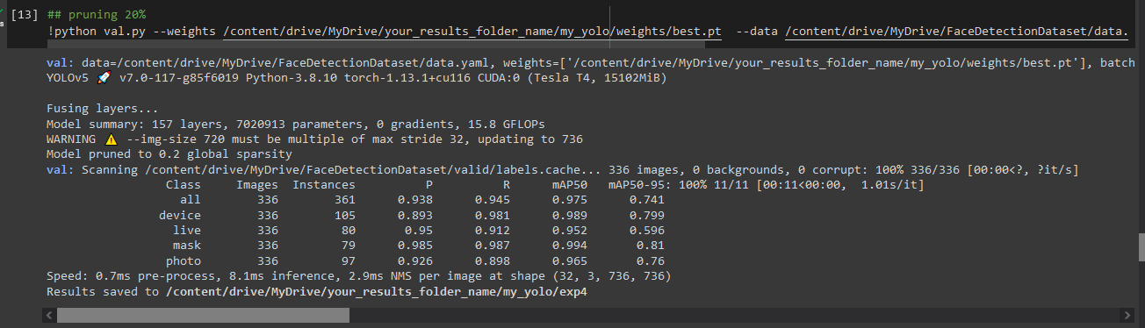

Pruning 30% of weights of the trained model on our custom dataset

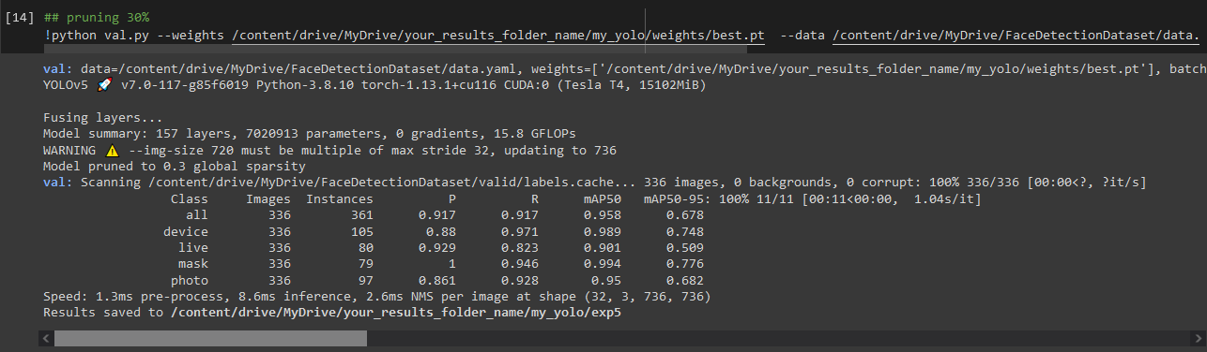

Pruning 40% of weights of the trained model on our custom dataset

